Newsletter ~March, 2019

ry

, 2017

Our Next General Meeting
Monday, March 4 @ 7:00 pm
Grange Hall, Sudbury Town Center
(Park behind the Town Hall)

March 4, 2019 Speaker
Betsy Habich

We have Betsy Habich coming to give us a trunk show/lecture titled "The Joy of Fabric (and thread)" on March 4th, 2019.
Betsy creates both pieced and appliqued pictorial quilts using freezer paper templates and beautiful thread painting.
Betsy Habich’s quilts have been juried into national and regional shows, including IQA in Houston, AQS in Paducah, MQX, and Quilters Gathering. Her work has been awarded ribbons at regional quilt shows including the Vermont Quilt Festival, The Gathering and MQX. Betsy has had several one-woman shows at local shows, shops, and libraries. She lives with her husband, cats, and fabric in Beverly Farms, MA.
Join in Betsy’s workshop posted on the next page
Tica deMoor, Programs

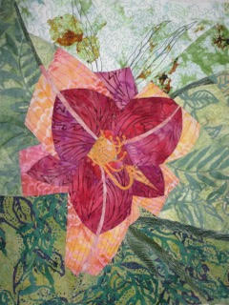
Daylily by Betsy Habich

In This Issue:

Betsy Habich speaker. & Wksp p. 1
OutReach p. 2
Survey p. 2
Guild Volunteers Needed p. 2
Sew Happy p. 3
Pin Pal Monthly p. 3
Board Meeting p. 3
April Speaker p. 3
Timna Tarr Workshop p. 4
May Speaker p. 4
Caring Hearts Pillows p. 4
Local Happenings p. 5 & 6
Guild Calendar 2019 p. 7
B.Habich Workshop Poster p. 8

Betsy Habich Workshop
When: Saturday, March 9, 2019
Time: 9:00 am – 4:00 pm
Cost: $45/member $55/nonmember

Learn how to see fabric differently and sew precise seams by using freezer paper templates while making Betsy’s Daylily pattern. We will select the right fabric, take advantage of variations in color and direction, to support the image we are making. We will use freezer paper templates, trace seam lines and registration marks. We will discuss approaches to quilting the pistils and stamen without piecing these finicky small parts. What color will your daylily be?
See attached poster at end of Newsletter.
Contact Laura Lane to sign up.
Pete.lane@comcast.net
OutReach

Reserve Saturday, March 9 for an OutReach sewing day at the First Baptist Church in Sudbury. We will provide fabrics and batting. The church space will have ample room for cutting and batting assembly.

For those who are attending the Betsy Habich workshop in another section of the same church on the same day, you can use your breaks to stop in to gather patterns and fabrics to sew up on their own time.

Susan Thomas & LuLinda Tucker
OutReach CoChairs

Wayside Quilt Guild Survey

At the last board meeting we began to discuss planning for the 2019 - 2020 year. There will be several board positions open, greater need for volunteers and an increased focus on growing our Guild. We felt it was time to get updated information on our current membership so we can plan appropriately for the future years. The 2019 Guild Survey was created by three members with input from the Board.

This survey is to find out what you want to get out of our Guild. Retaining current members, finding new ones and full participation from our membership are essential to keeping the Guild vibrant. Please take a few minutes to share your thoughts with us. We really would like 100% participation on this survey.
Link to survey below:
https://www.surveymonkey.com/r/N6BM5RX

Thank you!
Sue Blaney, Pat Lukens & Josee Vachon
Guild Volunteers Needed

What talents can you share with the Guild? The following positions need to be filled:

President: The President will preside at all general meetings and at meeting of the Executive Board. The President shall establish any committees she/he deems necessary and shall determine that all committees are filled and operational.

Secretary: The Secretary shall record the minutes of all Annual and General Meetings and meetings of the Board of Directors.

Workshop Co-Chair: The Workshops co-chairs oversee all details for each workshop including location, publicity, registrations, supply lists, coffee/tea at workshop. The co-chairs also pick up supplies from the guild storage, supervise room set-up on site, clean up and return of the supplies to the storage unit. Contact Laura Lane for more information.

Quilt Show Co-Chair: We are looking for another volunteer to share the job of overseeing the production of our Quilt Show 2020 with Kathy Cromwell and Carol Bradford. It will be fun and productive with three of us sharing the job!

Newsletter Editor Found: A big thank you to Michele MacDonald who has stepped forward to become our new Newsletter Editor for the next Guild year. Michele has done Newsletters for other groups and is confident in taking over the position. Michele will take over after Jean Konopacz retires in June.

Contact: infor@waysidequilters.org to volunteer or seek more information.

Sew Happy

Sew Happy will meet on Saturday, March 16 from 10-2 pm at St. Anne’s in the Fields, 147 Concord Rd. in Lincoln. There is a lot of table space in this venue to use. It would be a great place for basting a quilt. Bring along your projects as well as a small donation for church use.

Tricia Crockett

Pin Pal Monthly

JOIN NOW! Participate as a Wayside Quilters Pin Pal!! You will be part of team to make and swap pinwheel blocks for your quilt as a guild wide 2020 Quilt Show project.

As a Wayside Quilters Pin Pal you will need to make (a determined) number of 3.5" pinwheel blocks each month in the designated color, bring them to the monthly meeting and take your swapped ones home. At the end of the nine month swap you will have lots of blocks to arrange into anything quilted you desire for the 2020 Quilt Show. Designated colors with a contrasting light background are: April/green, May/pink, June/yellow, July/red, August/purple, September/rust, October/orange, November/gray and December/blue.

Please use a good quality quilting fabric and no "conversation" prints.
An online instruction video on “Getting a perfect Pinwheel” is available at:
https://www.rachelrossi.design/getting-a-flat-pinwheel-quilt-block/

Details and sign up at the March meeting.

Jill Cochrane
iyayajc@gmail.com
Next Scheduled Board Meeting

Saturday, April 20 at 1:00 at St. Anne’s Church in Lincoln. This meeting is planned to coincide with the Sew Happy group.

April 16, 2019 Speaker
Timna Tarr
Meeting Date Change

We are happy to secure Timna Tarr, a contemporary New England quilt artist, as our speaker in April 2019. Our meeting in April will take place on Tuesday, April 16 (instead of April 1) to accommodate her schedule.

Timna will give us a trunk show and lecture on her quilts as well as tell of her life as a quilt artist. Timna’s quilts are constructed using the format of traditional piecing techniques. She builds her quilts block by block, working the colors to play off of each other in a way that the resulting quilts are often infused with light and movement.
Timna’s quilts have won national awards and are in private and corporate collections. She is a sought-after teacher and speaker so we are excited to have her at WQG.

Tica deMoor
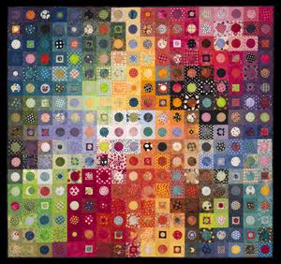
Timna Tarr “Happy Days”

Timna Tarr Workshop
When: Saturday, May 11, 2019
Time: 9:00 am – 4:00 pm
Project: Based on Happy Days Quilt
Cost: $45/member $55/nonmember

The workshop will be based on Timna’s Happy Days Quilt. Timna will work with the group on color and how to utilize it successfully in a quilt. She will also demonstrate numerous ways to work with circles on a quilt, using both hand and machine techniques. Visit her website at www.Timnatarr.com.
Contact Laura Lane to sign up.
Laura Lane
Pete.lane@comcast.net

May 6, 2019 Speaker
Gladi Porsche

We have Gladi Porsche coming to give us a trunk show on May 6th, 2019.

Gladi has recently had her quilts featured in a special exhibit at the New England Quilt Museum. Gladi is a physician, but quilting has been her hobby for many years, and she has created an amazing number of stunning quilts. She will give us a trunk show and lecture about all of her work.
Visit her website at www.Gladiquilts.net.

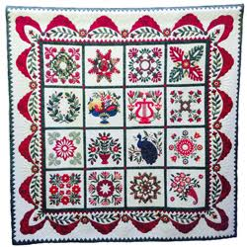
Imperfect Beauty by Gladi Porsche
WQ Caring Hearts Pillows
🧡 🧡️🧡

In January 2009 we began a guild activity for making pillows to give to our members when a little cheering up was in order and we needed to let a member know she was in our thoughts. They have been given at times of illness, surgery and the loss of a loved one, sending a sweet hug. It has always been lovely for us to hear how special it was to receive a pillow!

Sometimes we dedicate a guild meeting to working on making more pillows so we can keep a supply on hand - in the past we have made the February meeting one where we stitched - always nice to sew together for a good cause and it was also a good opportunity to learn how to appliqué. Sometimes members make pillows at home to keep the supply up.

The pillows are very pretty and feature four appliquéd hearts and are lightly quilted, some by machine and some by hand. As we have a good supply at present, we decided not to have a meeting this year, but will put it back in the schedule at another time.

Thank you to everyone who has helped sewing the pillows over the past 10 years. They are now moving to a new home - Jill Cochrane has kindly volunteered to keep them, and we are grateful to her for taking them over. Please contact Jill or a board member if you are aware of someone who should be on the receiving end of the guilds well wishes.

Marianne Hatton and Jane Harris

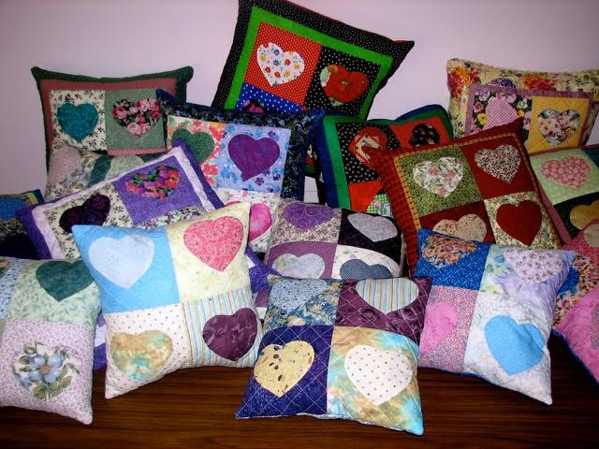
Caring Heart Pillows

Local Happenings

Old North Speaker Series
Quilts for the Cause:
Community Actions
The speaker will be Pamela Weeks,
presented in partnership with the New England Quilt Museum.

“Quilts for the Cause” include those used to promote social issues such as anti-slavery or prohibition, and for charitable or patriotic purposes, which include quilts made in time of war. Pamela Weeks, Curator of the New England Quilt Museum, will discuss quilts made for some of these issues.

Afterwards, join us for a reception with Pam and Sue Bleiweiss of “Thread of Resistance” for an intimate discussion on the parallels between the subversive and communal nature of quilting in the 19th century vs quilting today.
Date: Wed, March 13 from 6-8:30 PM
Location: Old North Church, 193 Salem St., Boston

For Tickets:
https://www.eventbrite.com/e/old-north-speaker-series-pamela-weeks-quilts-for-the-cause-tickets-56141948078
QUINOBEQUIN QUILTERS AUCTION

- Quilts, wall hangings, fabric, kits - and so much more!
- Featuring a “Grab & Go” table with a large assortment of fabrics, books, patterns, quilt
& craft related items, plus other treasures!
Tuesday, March 12, 2019
Doors open – 6:00 pm
Auction – 7:00pm
Congregational Church of Needham
1154 Great Plain Ave, Needham, Mass.
- Handicap accessible
o- Plenty of free parking
For more information and to view auction items, go to:
www.quinobequin.org

Workshop Openings Available

Marathon Quilters have a few seats left in an upcoming workshop with Timna Tarr.

The workshop is scheduled for Saturday, March 23, from 9 am - noon at the Faith Community Church in Hopkinton. Timna will lead an Improv Piecing workshop, which will include tips and tricks for creating your own improvised piecing. New techniques, including curved piecing, will be covered in this fun day of play and experimentation.

Space is limited to 20 quilters. Member price: $35. Non-Member price: $45.

Please email Jean Bertschmann, jeanber65@hotmail.com, to sign up. Timna's website, including the workshop description: http://www.timnatarr.com/workshops

Retreat Available

Beth Nadel Dorfman of the Concord Piecemakers is organizing a local get-away in April. The dates are April 6-8th (Saturday – Monday) at the West Pond Inn in Bolton. It is gorgeous and sits on a pond. Here is the link: www.westpondinn.com

The cost is $100 plus tax per night for overnighters and $75 for commuters. Breakfast and dinner are included.

A $75 deposit is needed upon sign-up.
There are 5 overnight spots open and 3 commuters.
Interested persons can email Beth at: idecorate@comcast.net

Quilt Guild Members Discount
Color Theory Class

The Umbrella Community Arts Center in Concord is offering a discount to all guild members when registering for the “Color Your Quilts” class, a class combining color theory with a hand on project.

Class starts April 3 and runs for 8 weeks, meeting on Wednesdays from 1-4:00 pm

Where: The Umbrella, 57 ORNC, Concord

To get your discount, go to: www.theumbrellaarts.org/class/color-your-quilts and use the code: QG-2019 for 12% off your class registration. If you have trouble or questions, email: Danielle at: Danielle@umbrellaarts.org

Machine Quilters Expo

Thursday, April 11-Saturday, April 13
DoubleTree Hotel, 700 Elm St., Manchester, NH
Check the website for hours, admission and parking info.

https://www.mqxshow.com/MQX/East/Home/index.cfm

Quilters’ Connection Quilt Show

Friday, May 17 – Saturday, May 18
St. James Armenian Church
465 Mount Auburn St., Watertown, MA
www.quiltersconnection.org

Vermont Quilt Festival

June 26-June 29
Champlain Valley Exposition, 105 Pearl St., Essex Junction, VT
www.vqf.org

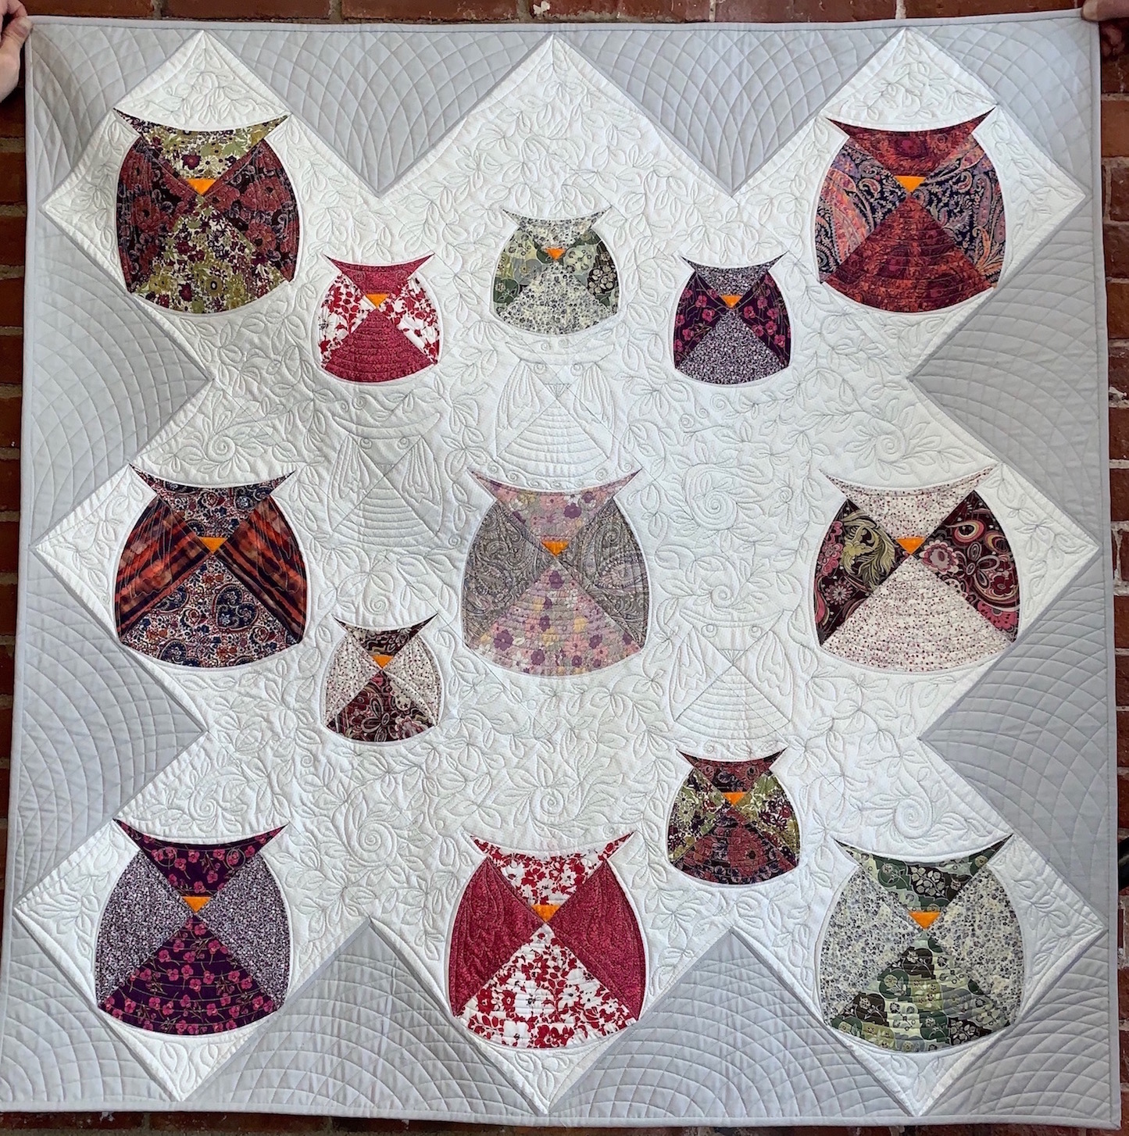
Liberty Owls by Jean Konopacz

WQG Calendar Reminders

2018 / 2019 General Meetings

Our meetings are the 1st Monday of the month, with the exception of a holiday. Members can bring show n’ tell to any non-speaker meeting.

2019:

Monday, March 4: Speaker Betsy Habich 7:00 pm

Saturday, March 16 10-2, Sew Happy
St Anne’s in the Fields, Lincoln

Saturday, March 9: Betsy Habich Workshop 9:00 am – 4:00 pm, First Baptist Church, 162 Landham Rd, Sudbury

Saturday, March 9: OutReach, 9:00 am – 4:00 pm, First Baptist Church, Sudbury

Tuesday, April 16, Speaker Timna Tarr
7:00 pm

Saturday, April 20, Board Meeting, St. Anne’s Church, Lincoln, 1:00 pm

Saturday, April 20, 10-2, Sew Happy
St. Anne’s in the Fields, Lincoln

Monday, May 6: Speaker Gladi Porsche
7:00 pm

Saturday, May 11: Timna Tarr Workshop
9:00 am – 4:00 pm, First Baptist Church, Sudbury

Monday ,June 3: End of Year Business & Show n Tell 7:00 pm

Newsletters and “Betweens”
Deadlines: 3 days before the 1st/15th
Send submissions to Jean Konopacz at
jkonopacz@gmail.com

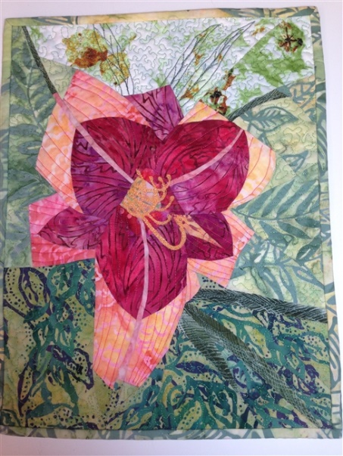

QUILTING WORKSHOP

Learn to sew precise seams with

BETSY HABICH

Discuss various approaches to quilting and

take home a daylily wall hanging

MARCH 9, 2019 9AM – 4PM $55.00

Sponsored by Wayside Quilters Guild

Contact: Pete.Lane@comcast.net

