Newsletter ~October, 2018

ry

, 2017

Quilt Show

Saturday,September 29 from 10-5:00 pm
Sunday, September 30, from 10-4:00 pm

Lincoln Sudbury Regional High School
cafeteria
390 Lincoln Road, Sudbury

Admission: $7.00
Children under 12 Free
Ample free parking
Wheelchair accessible

In This Issue:

Quilt Show . p. 1
Quilt Drop Off (New Info) p. 1
Show Set Up p. 2
Quilt Pick Up p. 2
Boutique p. 2
Poles/Slats/Pins p. 2
Raffle Tickets p. 3
Food at the Show p. 3
Is Your Show Quilt Ready p. 3
Naked Ladies p. 3
Sew Happy p. 3
Board Meeting p. 3
Next General Meeting p. 4
All Day OurReach Sewing p. 4
Future Speakers p. 4
Stump Sprouts Retreat p. 5
Area Quilt Shows p. 5
Guild Calendar 2018 / 2019 p. 5
Quilt Show Flyer p. 6 & 7
Stump Sprouts Flyer p. 8

Quilt Drop Offs

All quilts, in their cloth bags, along with their slats (if required) should be delivered on Thursday, September 27. Your name should be clearly printed on the cloth bag as well as the slat. A photo of the quilt should be inserted into a plastic sleeve attached to each cloth bag. Drop off addresses and times are below:

10:00 am – 12:00 pm OR
4:00 pm – 7:00 pm at the home of:
Pat Lukens
70 Melody Lane
Marlboro 508-251-2334

OR

4:00 – 7:00 pm at the home of:
Moira Ten-Hove
187 Oak Hill Circle
West Concord 978-876-3097
- Please note Moira’s house # was incorrect on the Betweens. This is the correct one above.

If you cannot be available during these times, please arrange to have a friend drop off your quilts for you.

Any items for the Boutique (to sell) or the Crafty Corner (for display) should be dropped off at the LSRHS cafeteria on Friday, September 28 between the hours of 4:30 – 8:00 pm.
Show Set Up

We are still looking for strong, able bodied helpers for show set up on Friday evening, September 28 from 4:30 to approximately 8:00 pm. You do not need to be there the entire time. Please show up when you are able. Bring along spouses, sons or grandsons Pizza will be served to those who help.

Things that would be helpful to bring if you have them:
Ladders or step stools, levels, wire cutters, screwdrivers, measuring tape, water bottle and patience.

Sign up below for Friday or any other weekend jobs:
https://www.signupgenius.com/go/10c044cadad28a5f58-quilt1

Quilt Pick Up

The show ends at 4:00 pm on Sunday and clean up will happen immediately. All quilts must be taken down, stored in their bags and sorted. All poles must be taken down, sorted and loaded into the UHaul. The LSRHS cafeteria will need to be swept and clean. Hoping we can all participate and have this done in an hour. ONLY AFTER CLEAN UP IS FINISHED can the quilts be picked up. If you cannot be available, ask a friend to do so for you.

Boutique News

There is still time and space to enter items into the quilt show boutique. Please email Gayle at sew1derful2@gmail.com to get an identification number. Or download an entry form from our website. The guild gets a percentage of sales, or you may choose to donate all your proceeds. These funds help the guild pay for speakers and workshops.
Gayle O’Bryan
Sew1derful2@gmail.com

Poles vs Slats vs Pins

If your quilt is 80” in length or longer, it will be hung on a pole and will only require a sleeve.

If your quilt is 30” – 79” in length, a slat is required. The slat should be a flat piece of wood, the width of your quilt x 1 ¾” wide x at least ¼” thick. This size was taken off the notes from the past shows. I was at Home Depot today and had a rough time finding this actual dimension. So I bought one that was close to it. Use your best judgement. Get a slat that fits into your sleeve and is not flimsy. There should be 3 holes drilled in the slat, one at each end and one in the middle. Any Home Depot or local hardware store can help you with finding, cutting and drilling the slat. Please use a marker to print your name and quilt name on the slat.

Any quilt smaller than 30” long will be hung with pins on a white sheet bordering the perimeter of the show room. These will include the Challenge quilts or smaller workshop quilts.
Raffle Tickets

So far we have collected $2669.00 of raffle ticket sales from guild member plus sales at different venues. Please continue to sell tickets. Bring any ticket stubs to the Show.

Please return any unused tickets in your possession. They can be returned to the raffle quilt table before or during the Show.

Betsy Athan
Athanfamily@comcast.net
Raffle Ticket Sales

Food at the Show

This year we are keeping the food situation as simple as possible. There will be a behind the scenes section where members can grab a snack, eat their brown bag lunch or make a cup of tea. You are welcome bring a snack to share if it is finger food and does not need refrigeration. We will not be doing elaborate spreads as they require a lot of cleanup and raise food safety issues.
Thank you.
-Tricia Crockett

Is Your Quilt Ready for the Show?

- Sleeves: For any quilt over 30” in length.
- Lattice Strips: Quilts 30” – 79” in length with 3 holes drilled at each end and middle. Label with name
- Labels: Stitched onto the back bottom right corner. Name of Quilt, Maker, Date of Completion.
- Cloth Bags: Each quilt should be dropped off in a cloth bag with a drawstring and plastic pocket with name on it.

Reunion of the Naked Ladies

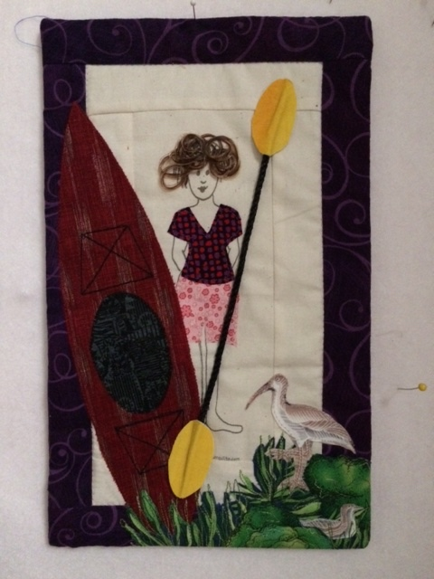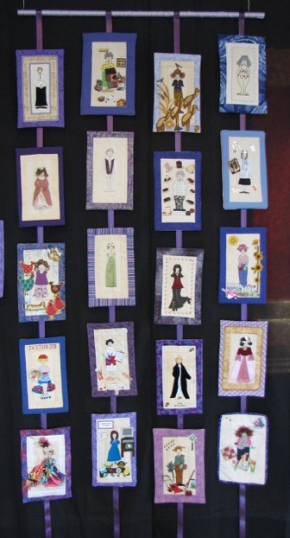

WQ members began making the little naked Lady quilts several quilt shows ago and we will get them together again for this show. Please plan on bringing yours to display. If you haven’t entered them on the entry forms it is still ok. They may be dropped off with your quilts 9/28 or even brought to set up on 9/29.

The Ladies are an easy last minute project if you have one but haven’t dressed her yet!
There will be some of the blanks plus instructions available at the next meeting on Sept. 10th. Please add one to the display!

Marianne Hatton & Jane Harris

Sew Happy

Sew Happy will be scheduled on the 3rd Saturday of the month from 10 am – 2:00 pm at St. Anne’s in the Fields in Lincoln. Next meeting October 20. A small donation is appreciated

Next Meeting of the Board

The next Board meeting will be held on Saturday, October 20 from 1:00 – 3:30 pm at the home of Kathie Cromwell in Wayland. Everyone is invited as we appreciate your input.
Next Meeting Monday, October 1
Next General Meeting
Monday, October 1, 2018

Grange Hall, Sudbury Town Center
(Park behind the Town Hall or go into the front drive of the Peter Noyes School and to the back of the lot.)

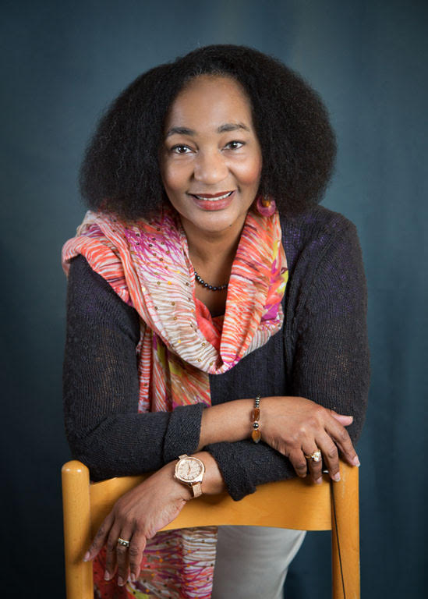

We are excited to announce our speaker for the October 1 meeting will be Valarie Poitier discussing “When Thought and Thread Collide”. This will be a motivational lecture and trunk show focusing on her process and on being a quilt artist.

Valarie will share her personal journey of quilting. We will follow her progress from exhibiting locally to being part of international exhibitions. She will share her process from idea to finished quilt, using traditional quilting techniques, especially strip quilting, story telling and research to inform her work.

Valarie’s “Nelson Mandela” quilt has just returned from an extensive tour. She is excited to share the story of this quilt with us.

Join us on Monday, October 1st. Feel free to bring a friend along for a $5 fee.

Tica deMoor
OutReach in November

Our November meeting will be a FULL day of OutReach sewing. Come join us for as much time as you can spare to sew for the organizations we support with our quilts: Camp Erin, REACH, Trust House, Pathways Shelter and Care Dimensions Hospice.
Date: Monday November 5th
Time: 2 pm-8 pm
(replaces November’s meeting)
Where: St. Anne’s Church, Lincoln
Bring your sewing machine and kit

We will supply fabric, batting, and patterns.
We’ll also provide refreshments. It’s a great time to learn and support each other in the process!
Lulinda Tucker & Susan Thomas

Speaker for April 2019 and
Meeting Date Change

We are happy to secure Timna Tarr, a contemporary New England quilt artist, as our speaker in April 2019. Our meeting in April will take place on Tuesday, April 16 (instead of April 1) to accommodate her schedule.

Timna will give us a trunk show and lecture on her quilts as well as tell of her life as a quilt artist. Timna’s quilts are constructed using the format of traditional piecing techniques. She builds her quilts block by block, working the colors to play off of each other in a way that the resulting quilts are often infused with light and movement.

Timna’s quilts have won national awards and are in private and corporate collections. She is a sought-after teacher and speaker so we are excited to have her at WQG.
Tica deMoor
Stump Sprouts Retreat

Reservations are being taken for the annual Stump Sprouts 2019 retreat. See flyer p. 8

Marianne Hatton & Michele MacDonald

Area Quilt Shows

Rising Star Annual Quilt Show
Fri., Oct. 5: 10-6, Sat.,Oct. 6: 10-5
Saturday, Oct. 6 10 am-5 pm
Admission: $7, children under 12 free
Handicap accessible
St. Brigid Church
1995 Massachusetts Ave, Lexington
www.risingstarquilters.com

Concord Piecemakers Yard Sale
Yards of fabric, knitting and craft supplies, along with books, patterns and magazines
Saturday, Oct. 13, 2018, 9AM-2PM
St. Matthew’s United Methodist Church
435 Central St. Acton, MA
www.concordpiecemakers.org

Plymouth County Cranberry Quilters
“Fabricadabra, The Magic of Quilts”
Saturday, October 20 10 AM-4:00 PM
Admission $8
Carver Middle School
60 South Meadow Rd.
Carver MA
www.occqg.com

The Nimble Thimblers Quilt Guild Auction
Tuesday, October 30
Doors open 6:30 pm, Live auction 7:00 pm
Admission Fee, Plenty of parking, No Stairs
Cash or Check only / No charges
Crystal Community Club
77 Preston St., Wakefield

WQG Calendar Reminders

2018 / 2019 General Meetings

Our meetings are the 1st Monday of the month, with the exception of a holiday. Members can bring show n’ tell to any non-speaker meeting.

2018:
September 29 & 30: Quilt Show at Lincoln- Sudbury Regional High School

October 1: Speaker Valarie Poitier

October 20: Sew Happy 10 – 2:00
(meets 3rd Saturday of each month)

October 20, Saturday, Board Meeting

November 5: All day Outreach Sewing St. Anne’s Church, Lincoln

November 17: Sew Happy

December 3: Quilt Show review, Potluck & Show n’ Tell

2019:
January 7: Movie Night
February 4: In-house Demo Night
March 4: Speaker
April 16 (Tuesday): Speaker Timna Tarr
May 6: Speaker
June 3: End of Year Business & Show n Tell

Newsletters and “Betweens”
Deadlines: 3 days before the 1st/15th
Send submissions to Jean Konopacz at
jkonopacz@gmail.com

